 | Bansilal Ramnath Agarwal Charitable Trust’s Vishwakarma Institute of Information Technology  Department of  Artificial Intelligence and Data Science
Student Name: Sathe Onkar Abasaheb
Class: TY | Division: B |  | Roll No: 372078
Semester: V |  | Academic Year: 2025-2026
Subject Name & Code: Cloud and DevOps
Assignment No: 01
Title of Assignment:Execute basic Linux commands (file operations, process management,
user management)

Date of Performance: / /2025 |  | Date of Submission: / /2025

Aim: To execute Linux commands (file operations, process management, user management)

Objective: To learn basic Linux commands like file operations, process management and user management

Materials Required: Laptop with Arch Linux(OS kernel Linux 6.12.45-1-lts) installed in it, zsh(highly configured .zshrc).

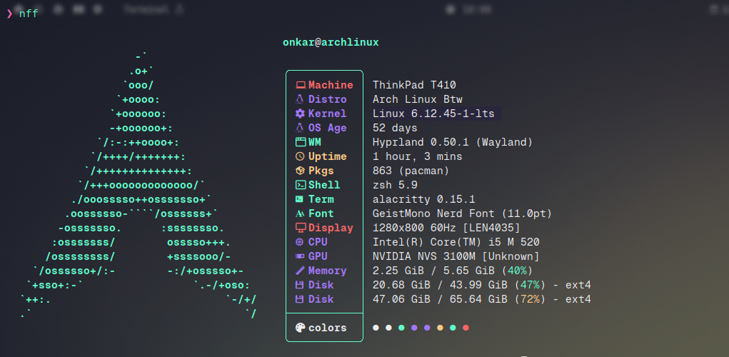

Procedure:

File Operations: File Operations are tasks performed on files and directories such as creating, copying, moving, and deleting.
- Commands used:
  - touch – Create a file
  - cp – Copy files/directories
  - mv – Move or rename
  - rm – Remove
  - ls – List contents
  - cat, more, less – View file contents
  - chmod, chown – Manage permissions and ownership
Purpose:
To organize data, manage storage, and control access.

Step 1: Open terminal Step 2: Create a folder
Step 3: Create a new text file Step 4: Rename the text file Step 5: Write text in the file Step 6: Delete the file and folder

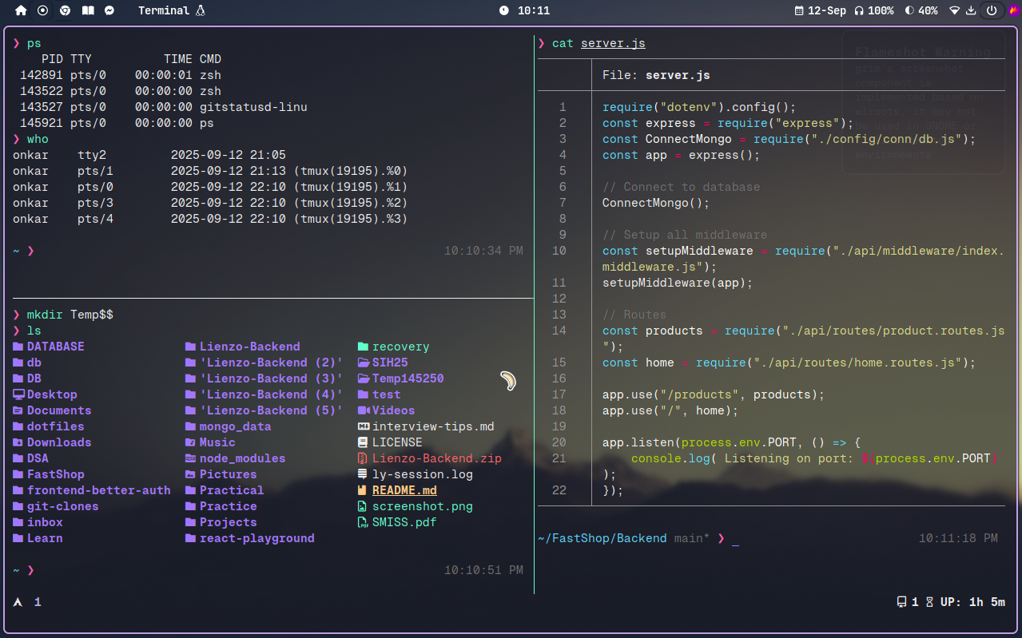
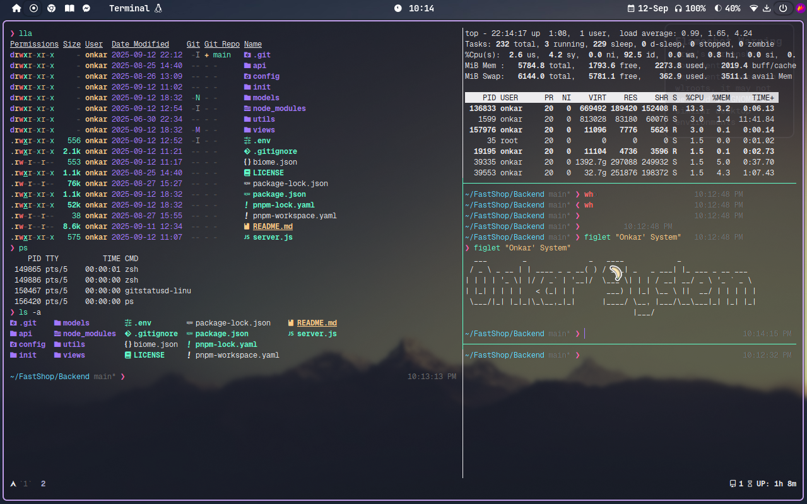

User Management:
User Management refers to creating, modifying, and deleting user accounts in an operating system. It ensures system security and resource access control.
- Commands used:
  - adduser / useradd – Add a new user
  - passwd – Set or change user password
  - deluser / userdel – Delete a user
  - usermod – Modify a user account
- Groups are used to manage permissions for multiple users together. Purpose:
To provide personalized environments and restrict access based on roles.

Step 1: Open Terminal
Step 2: Command to display username Step 3: Command to add a user
Step 4: Command to add new password of the user

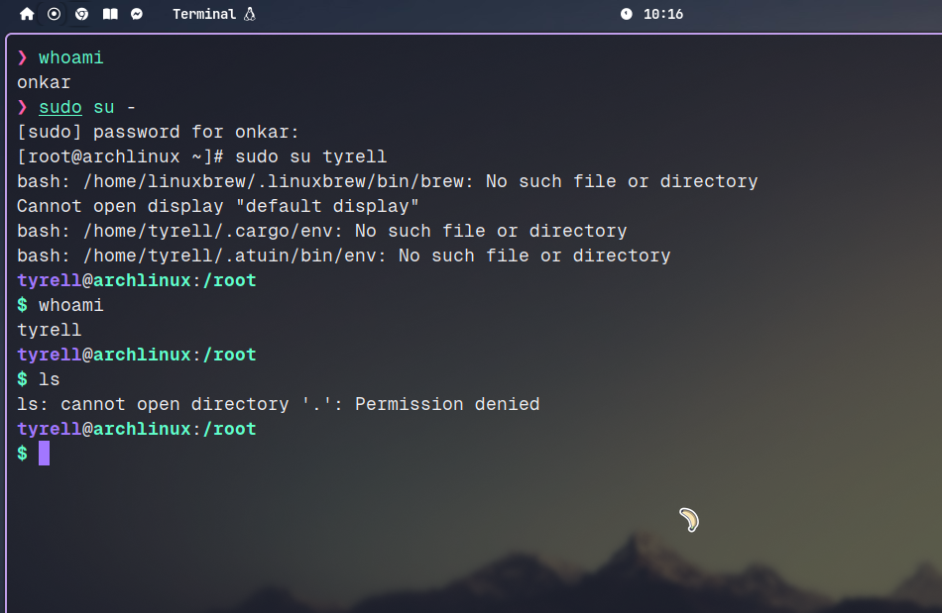

Permission Management Commands:

chmod - Change file permissions
chown - Change file ownership
chgrp - Change group ownership
umask - Default permission mask

Text Processing & Search

cat - Concatenate and display files

less - View file content one screen at a time

head - Show first lines of file

tail - Show last lines of file

grep - Search text using patterns

find - Search for files

locate - Find files (fast, indexed)

Process Management

ps - Show running processes

top - Real-time system monitor

htop - Interactive process viewer

kill - Terminate process by PID

killall - Kill process by name

bg - Resume background job

fg - Resume foreground job

jobs - List active shell jobs

nice - Start process with priority

renice - Change priority of running process

- Networking

ping - Send ICMP echo request

ip addr - Show IP addresses

ifconfig - Configure network interfaces (older)

netstat - Show network status (deprecated)

ss - Show sockets (modern replacement)

curl - Transfer data via HTTP

wget - Download files from web

scp - Secure file copy over SSH

ssh - Secure shell access

ftp/sftp - File transfer protocols

traceroute - Trace network route

dig/nslookup - DNS queries

hostname - Show or set hostname

Conclusion:
Though this assignment I expolored the Linux OS(Arch BTW), where I explored to mange everything from cursur to window manger and config files of each indivisual application I am using(Neovim, zsh, tmux and etc)
Along with that I learned to mange users, basic commands and etc.

